1. **Agenda:**
   1. We are going to create Kafka Producer that is going to produce a msg to the Kafka Cluster.
2. 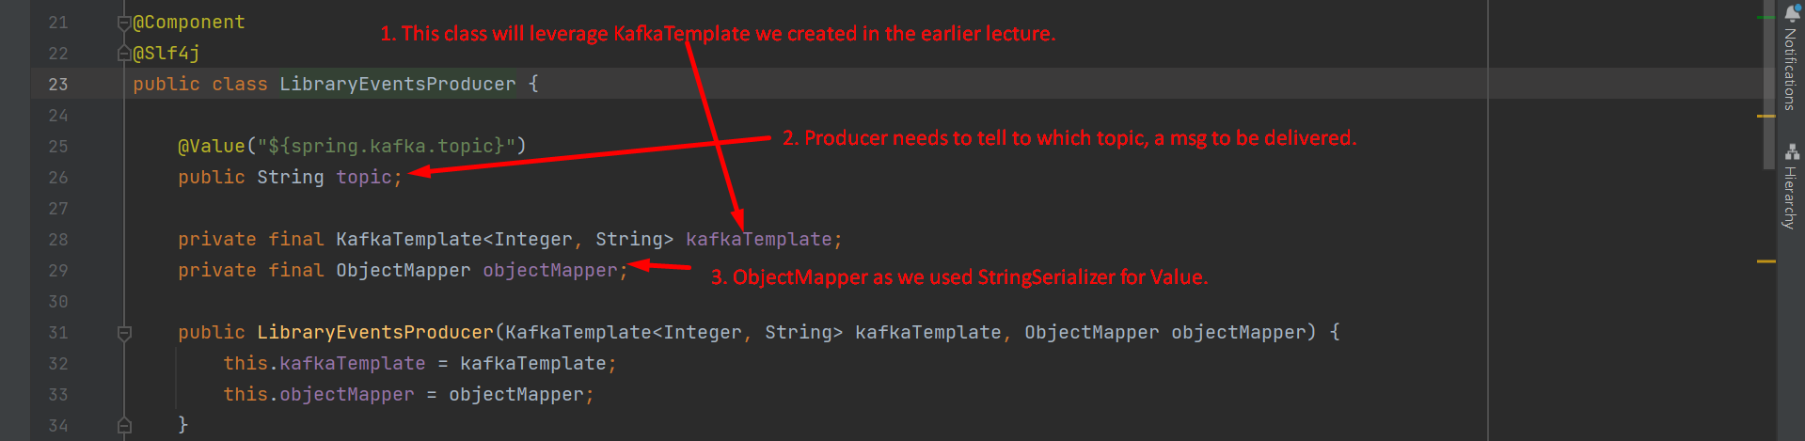  
     
   KafkaTemplate will be created by KafkaAutoConfiguration.java’s method kafkaProducerFactory() and we have defined its configuration in application.yml file.   
   